Yazhuo Liu
Homework 4

Write a program that finds the knot vector ( u0, ..., un-1 ) of a B-spline. It asks for 'number of control points' and 'degree of spline' as inputs and prints out the knot vector.
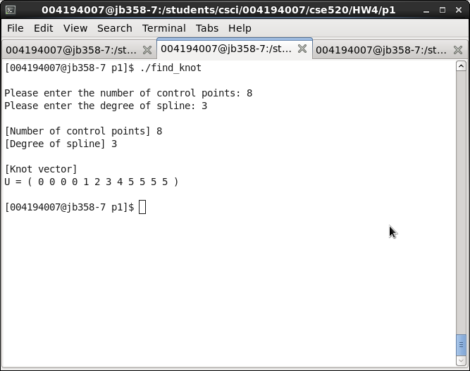
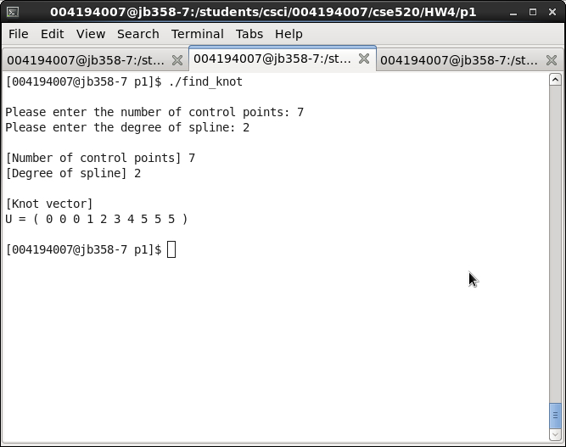
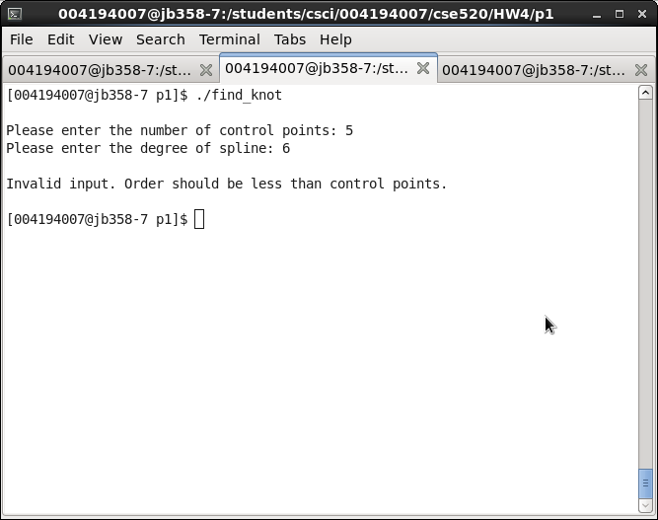
Code:

/*****************************************************************************

knot.cpp
This program finds the knot vector ( u0, u1, ..., un-1 )
of a B-spline. The program finds the knot vecotr by using the
steps provided in our lecture notes, then store each knot in
a vector.

******************************************************************************/

#include <iostream>
#include <vector>

using namespace std;

int main()
{
int cpoints, degree, i;

cout << endl << "Please enter the number of control points: ";
cin >> cpoints;
cout << "Please enter the degree of spline: ";
cin >> degree;

int order = degree + 1; //order is 1 less than degree
int value = 1;
int size = cpoints + order; //number of knots = control points + order

if (order > cpoints) { //knot vector only exists when order <= control points
cout << endl
<< "Invalid input. Order should be less than control points. \n" << endl;
return 0;
}

vector<int> kv; //store each knot value

//First m knots, u0, ..., um-1 all have value 0
for (i = 0; i < order; i++)
kv.push_back(0);

//Knots um, ..., un-1 increases in increments of value 1, from 1 to n - m
for (i = order; i < cpoints; i++)
kv.push_back(value++);

//The final m knots, un, ..., un+m-1 are all equal to n - m + 1
for (i = cpoints; i < size; i++)
kv.push_back(value);

cout << endl << "[Number of control points] " << cpoints;
cout << endl << "[Degree of spline] " << degree;

//print out the knot vector
cout << endl << endl << "[Knot vector] \nU = ( ";
for (i = 0; i < kv.size(); i++)
cout << kv[i] << " ";
cout << ")" << endl;

cout << endl;

}

Write a program that plots all the blending functions of degree 3 ( m = 4 ) on the same screen.

Cubic interpolating polynomial is used to find a point for a certain value of the parameter u. Suppose the points at u = 0, 1/3, 2/3, 1 are:
P(0) = ( 0, 0, 0 )
P(1/3) = ( 1, 2, 2 )
P(2/3) = ( 2, 3, 4 )
P(1) = ( 4, 5, 8 )
Find the point at u = 0.8.
Formula used: P = AC C = A-1P
For ease of use, I used a matrix calculator online to get the results.
First, I calculated the inverse of A.
A-1:
№ | A1 | A2 | A3 | A4
1 | 1 | 0 | 0 | 0
2 | -115/34 | 63/17 | -9/34 | -1/17
3 | 9/17 | -45/34 | 18/17 | -9/34
4 | 63/34 | -81/34 | -27/34 | 45/34

Then I used C = A-1P to calculate C:

№ | C1 | C2 | C3
1 | 0 | 0 | 0
2 | 50/17 | 215/34 | 100/17
3 | -9/34 | -27/34 | -9/17
4 | 45/34 | -9/17 | 45/17

Then I multiplied the results and A, which I got from the question, to get the final results:

№ | C1 | C2 | C3
1 | 1216/425 | 9094/2125 | 2432/425

Therefore, when u = 0.8, P(0.8) = ( 2.86, 4.28, 5.72 )

Write a program that uses B-splines and some control points to generate a profile and then use the profile and surface of revolution to generate a graphic chess piece like the one shown in class notes.
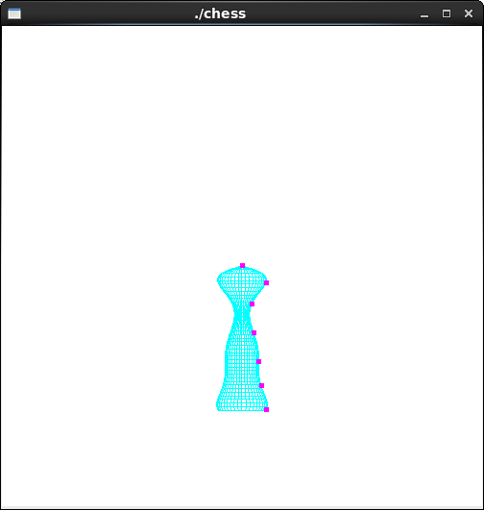

I added some control points to draw the chess piece. I chose to draw a pawn, although it does not look quite like the actual piece, this is the best I could do. I tried to use 14 control points instead of 7, but somehow that didn't work.
Code:
//chess.cpp
...
GLfloat ctrlpoints[7][3] = {
{ 0.0, 0.0, 0.0 }, { 0.35, 0.5, 0.0 },
{ 0.8, 0.2, 0.0 }, { 1.4, 0.25, 0.0 },
{ 2.0, 0.35, 0.0 }, { 2.5, 0.4, 0.0 },
{ 3.0, 0.5, 0.0 }//, { 1.6, 0.25, 0.0 },
};
...

void display(void)
{
int i, j;
float x, y, z, r; //current coordinates
float x1, y1, z1, r1; //next coordinates
float theta;

glClear(GL_COLOR_BUFFER_BIT);
glColor3f(0.0, 1.0, 1.0);
const float startx = 0, endx = 3;
const int nx = 40; //number of slices along x-direction
const int ntheta = 40; //number of angular slices
const float dx = (endx - startx) / nx; //x step size
const float dtheta = 2*PI / ntheta; //angular step size

x = startx;
//r = aLine ( x );
r = polyint( ctrlpoints, x, 7);
glPushMatrix();
glRotatef( anglex, 1.0, 0.0, 0.0); //rotate the object about x-axis
glRotatef( angley, 0.0, 1.0, 0.0); //rotate about y-axis
glRotatef( anglez, 0.0, 0.0, 1.0); //rotate about z-axis

for ( i = 0; i < nx; ++i ) { //step through x
theta = 0;
x1 = x + dx; //next x
//r1 = aLine ( x1 ); //next f(x)
r1 = polyint( ctrlpoints, x1, 7); //next f(x)
//draw the surface composed of quadrilaterals by sweeping theta
glBegin( GL_QUAD_STRIP );
for ( j = 0; j <= ntheta; ++j ) {
theta += dtheta;
double cosa = cos( theta );
double sina = sin ( theta );
y = r * cosa; y1 = r1 * cosa; //current and next y
z = r * sina; z1 = r1 * sina; //current and next z

//edge from point at x to point at next x
glVertex3f (x, y, z);
glVertex3f (x1, y1, z1);

//forms quad with next pair of points with incremented theta value
}
glEnd();
x = x1;
r = r1;
} //for i

/* The following code displays the control points as dots. */
glPointSize(5.0);
glColor3f(1.0, 0.0, 1.0);
glBegin(GL_POINTS);
for (i = 0; i < 7; i++)
glVertex3fv(&ctrlpoints[i][0]);
glEnd();
glPopMatrix();
glFlush();
}

Report:
I successfully finished problem 1, 3, and 4 of the homework.

